Kermode

Found only in British Columbia's northern forests, the rare "Spirit Bear" or "Kermode Bear" is a sub-species of the black bear and is widely recognized for its unique white colouring. The territory of the Kermode is about 7.2 million hectares. They exist in the wilderness regions from Princess Royal Island to Prince Rupert Island, Terrace and East Hazelton. Other Kermodes can be reddish, gray, yellow, or even orange...but about one in ten show the white "spirit bear" coloration.
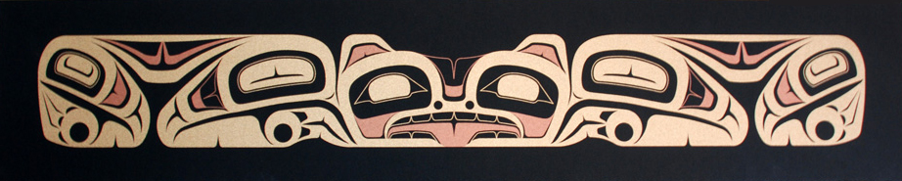

A Tsimshian legend gives a different explanation for the origin of the bear. Long ago, the world was covered in ice and snow. One day, the raven, the creator of the world, came down from heaven and turned the world green, as it is today. But as a reminder of the time when all was white and the hardships that resulted, the raven went among the bears and turned every tenth one the color of snow. The raven decreed that the white bear, which the Tsimshian call Moksgm'ol, would live in peace and harmony forever.

Named in 1928 after Dr. Francis Kermode, director of the BC Provincial Museum, the Kermode (Ursus americanus kemodei) is now protected by law. This reclusive bear seeks mountainous terrain and deep forests, along with the salmon streams that cut through the northwest, feeding on wild berries, insects, salmon and small game.

Artist Bio


My Native American ancestry is through the Gitksan (Gitxsan) tribe in Hazelton (Gitanmaaxs) B.C. Canada. I am a member of the Wolf clan (Lax Gibuu), house of "Amagyet". My mother's grandparents are Peter Gordon Wilson and Amelia Angus both from the Hazelton / Kispiox (Ans'payaxw) area. I was raised in Terrace, B.C. and spent most of my time working on our family farm with my brothers and sisters.
At the age of 10 I was first introduced to the artwork by two instructors who came to our elementary school and taught a number of basic art lessons to our fourth grade class. Both instructors were very skilled artists and that first impression left a lasting mark in my mind.
At age 11, my mother, Lynda Wilkerson, arranged for private lessons with Freda Diesing. I learned the basic rules and concepts of the artwork and became familiar with most of the animals and their distinguishing characteristics. I was also fortunate in that we spent a good deal of time carving a number of pieces from Red and Yellow Cedar. From these lessons I was able to learn the basics of wood carving and how to take a concept from a simple sketch to a finished product.
I owe a great deal to Freda Diesing for the training I have received and also for the influence her work has had on my own. I prefer a more classical approach in my artwork with heavier form lines and a curvilinear style that blends both Haida and Tsimshian traditions.
My wife, Cynthia Wilkerson, is very supportive of my artwork and often assists in the composition of many of my pieces. We have five very active children and it is only with her support that I am able to take the time to generate new ideas and then execute them to the best of my ability.
Nathaniel P. Wilkerson

